Skyline Custom and Live Reports

The Skyline Targeted Proteomics Environment provides informative visual displays of the raw mass spectrometer data you import into your Skyline documents. It allows you to work with this data, to refine the peptides and transitions you are measuring and to tune integration boundaries. A rich variety of calculated values and statistics may be exported from your Skyline document to a tabular comma separated value (CSV) file perfect for further analysis in tools like Excel and R. The Skyline Results and Document Grids provide Live access to many of these values and allow you to edit custom annotations as you work with your data.

The first part of this tutorial will focus on Skyline custom reports. You will learn how they can be designed, shared and used to export raw values and summary statistics from your Skyline documents. Exported reports can be used in the following ways:

* Deeper statistical analysis in tools like Excel or R
* Broader statistical analysis across multiple experiments and/or laboratories
* Enforcing instrument quality control with summary statistics
* Providing an input format for other custom build software tools
* Providing an import format suited to relational data repositories

In developing Skyline we aim to create a vendor-neutral platform for targeted proteomics investigation. Skyline can export similar custom reports for documents populated with the data from Agilent, AB Sciex, Bruker, Thermo-Scientific and Waters instruments. The ability to create consistent reports across instrument platforms greatly facilitates cross-instrument comparisons and large multi-site studies.

Understanding how to create custom reports, tailored to your own experiments, is critical and described in detail in this Skyline custom reports tutorial.

The second part of this tutorial will focus on the Results and Document Grid views in Skyline, which provide real-time access to many of the data fields available in the custom reports. You will learn to customize columns in the Results and Document Grids for immediate access to important values, as you inspect and refine your mass spectrometer output in Skyline. You will also learn to work with custom annotations to provide a controlled vocabulary for further interpretation of and human interaction with your results, which can also be exported in custom reports.

# Getting Started

To start this tutorial, download the following ZIP file:

<https://skyline.gs.washington.edu/tutorials/CustomReports.zip>

Extract the files in it to a folder on your computer, like:

C:\Users\brendanx\Documents

This will create a new folder:

C:\Users\brendanx\Documents\CustomReports

Now open the Study7_example.sky file in this new folder by double-clicking, or by using **Open** on the **File** menu in a running instance of Skyline.

# Data Overview

The dataset in Study7_example.sky is a subset of a study that was performed by the Clinical Proteomics Technology Assessment for Cancer (CPTAC) consortium (T. Addona et al “Multi-site assessment of the precision and reproducibility of multiple reaction monitoring–based measurements of proteins in plasma”, *Nature Biotechnology*, **2009**, 27, 633 - 641). This particular study describes a calibration curve at different concentrations of analyte peptides and a constant spike in level of their corresponding isotope labeled internal standards.

The Skyline file displays data from a subset of CPTAC Study 7.2 data (in the paper referred to as “Study II”) acquired at one CPTAC site. The Skyline file shows data for 10 different peptide sequences monitored by LC-MRM-MS with concentrations for the analyte proteins (see light peptides) ranging from concentrations at 500 fmol to 2.92 fmol (replicates J: 500 fmol; I: 275 fmol; H: 151 fmol; G: 83 fmol; F: 46 fmol; E: 25 fmol; and D: 8.55 fmol – lower concentration points although acquired are not included in this tutorial). Heavy internal standard (IS) peptides are each spiked in at a concentration of 50 fmol.

To get a first impression what this dataset looks like perform the following steps:

* Click on the ‘HGFLPR’ peptide to highlight it.
* On the **View** menu, choose **Peak Areas**, andthen click **Replicate Comparisons**.

A new window appears that shows peak area for each replicate. The blue bars represent the heavy labeled version of this peptide (always spiked in at 50 fmol), and the red bars represent the light analyte at varying concentrations (each concentration point was acquired in technical quadruplicate).

Other tutorials describe how you can view and edit documents like this one. For the purposes of this tutorial, however, the Study7_example.sky document has received an initial integration review, fully preparing if for reports to be exported and used in deeper statistical analysis. Before continuing with the rest of the tutorial:

* Close the **Peak Areas** view.

# Creating a Simple Custom Report

To create your first Skyline custom report template, perform the following steps:

* On the **File** menu, choose **Export**, and click **Report**

An **Export Report** form will appear that will probably list at least the Skyline default report templates shown below:

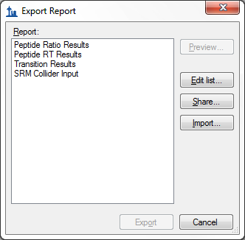

Continue creating a new Skyline custom report template by performing the following steps:

* Click the **Edit list** button.
* In the **Edit Reports** form, click the **Add** button.
* In **Edit Report** form, enter ‘Overview’ in the **Report Name** field.

The form should now look like:

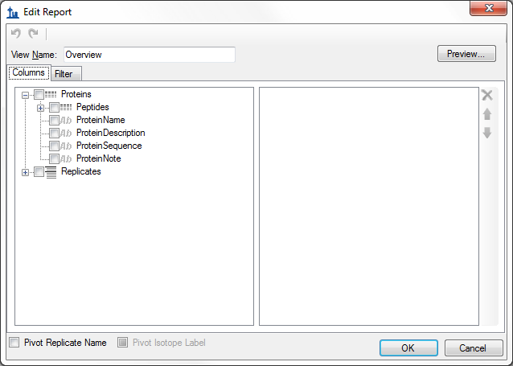

* Expand the field groups **Peptides** and **Replicates** by clicking on the **‘+’** button to see many more fields that can be exported.
* From the expanded **Peptides** group click the checkbox next to the **PeptideSequence** field.

The form should now look like:

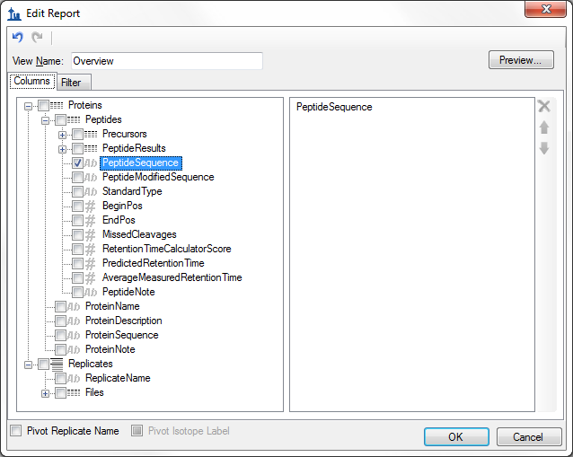

Note that the fields in the **Edit Report** form, shown above, have a distinct hierarchical structure. At the highest level are the *protein specific export fields* which are shown at the bottom of the left box (**ProteinName**, **ProteinDescription**, **ProteinSequence**, **ProteinNote**, and the expanded **Replicates**group below these that contains the general field **ReplicateName**). Skyline custom reports also provide *peptide specific* *export fields*, contained in the expanded **Peptides** group at the top of the left box, such as **PeptideSequence** and **AverageMeasuredRetentionTime** among others. The peptide fields include a **PeptideResults** group, which is not expanded yet. Also unexpanded is the **Precursors** group, which contains *precursor specific export fields*, a **PrecursorsResults** group, and finally a **Transitions** field group. The **Transitions** group, in turn, contains the *transition specific export fields* and a corresponding **TransitionResults** group, containing the most detailed results values, such as **Retention Time, Fwhm, StartTime, EndTime, Area** and **Background**, from which many of the higher level results field values are derived .

In the Edit Report form continue to add fields to your first custom report template by performing the following steps:

* Expand the **Precursors** group (located directly below the expanded **Peptides** group at the very top) by clicking on the ’+’ icon.
* Expand the **PrecursorResults** group field now visible in the expanded **Precursor** group.
* Click the checkbox next to the **IsotopeLabelType** field from the expanded **Precursors** group. (If necessary, scroll down or resize the form.)
* Repeat this procedure to add the following additional fields from the precursor **PrecursorResults** group to the report template column list:
  + **BestRetentionTime -** the **RetentionTime** value of the transition with the highest maximum intensity for the particular precursor
  + **TotalArea** - the summed **Area** values of all individual transitions for the particular precursor (for more information on field values, see Glossary)
* Check the **Pivot Replicate Name** check box in the lower left corner of the **Edit Report** form.

This should leave the **Edit Report** form looking like:

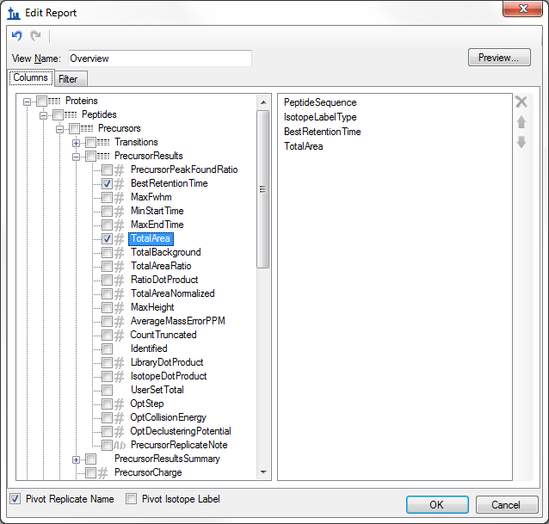

* Click the **Preview** button in the upper right corner of the **Edit Report** form.

The **Preview** form should appear looking like:

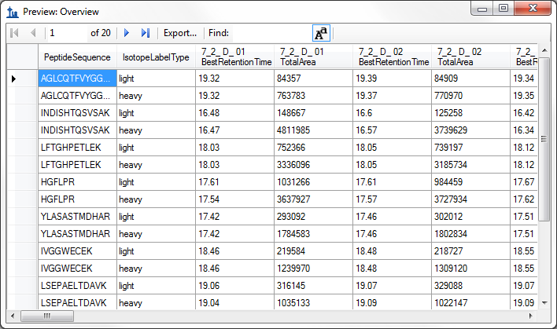

The Preview function is quite helpful when designing report templates. At times it may even serve as a quick substitute for exporting a report to a file, since you can select all of the values in the **Preview** form by clicking the upper-left rectangle. Pressing Ctrl-C, then copies the full report. After which, it can be pasted into another tool, like Excel.

The report preview displayed in part above, for replicates 7_2_D_01, and 7_2_D_02, shows precursor **BestRetentionTime** and **TotalArea** for all 10 peptides in both their light and heavy form across all LC-MRM-MS acquisitions/experiments in the columns to the right. By scrolling to the right, you can see columns for all 28 LC-MRM-MS acquisitions. Maximize the **Preview** form by clicking on the square in its upper right corner to see more columns. In this example 7_2_D_01, and 7_2_D_02 are taken from samples at the same light analyte concentration. Therefore, TotalArea values are expected to be similar. Each letter D through J indicates a different light analyte concentration. Each concentration was acquired in technical quadruplicate, indicated by numbers 01 through 04. The heavy peptide concentrations were held constant at 50 fmol in all samples.

Close the Preview Report form by clicking on the ‘x’ in the upper right corner to return to the **Edit Report** form again. To save this report template:

* Click the **OK** button.

You will see the new **Overview** report template appear in the **Report** template list.

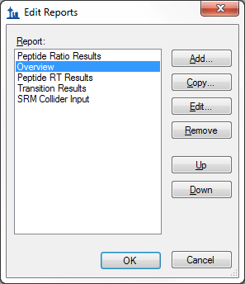

* Click the **OK** button again to return to the **Export Report** form.

The new **Overview** report template is now added to the Skyline report template list. The **Export Report** form should now look like:

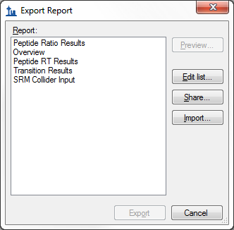

From the **Export Report** form you can now export your new report by selecting ‘Overview’ in the **Report** list and clicking the **Export** button. For now, click the **Cancel** button, dismissing all open forms, in order to start the process from the original Skyline document view.

# Exporting Report Data to a File

To export the report you created and previewed above to a CSV file, do the following:

On the **File** menu, choose **Export**, and click **Report**.

* Select ’Overview’ in the **Report** list of the **Export Report**.
* Click the **Export** button.
* Enter ‘Overview_Study7_example.csv’ in the **File name** field of the **Export Report** save form.
* Click the **Save** button.

If you switch to a Windows Explorer window, showing the CustomReports folder you created for this tutorial, you will see the Overview_Study7_example.csv file you just created. Open it now with Excel and confirm that its contents are quite similar to the preview you displayed earlier. Note that the file contains the column header names, which you cannot get by simply copying and pasting from the preview form.

# Sharing Report Templates

Report Templates in Skyline are very flexible, easy to manage and modify, and share with collaborators.

There are many reasons you might want to share a custom report template, whether you are participating in a large multi-laboratory study or working with a single collaborator, whether you are providing the proteomics community with your own custom tool that depends on particular fields from Skyline documents or providing supplementary information with a manuscript to allow others to repeat your protocols. The Skyline support for instruments from multiple vendors means your shared report templates can be used to gather data from multiple sites with different instrumentation.

To share the Skyline report template you created in this tutorial, perform the following steps:

* On the **File** menu, choose **Export**, andclick **Report**.
* Click the **Share** button in the **Export Report** form.

Skyline will present the **Save Report Definitions** form, as shown below:

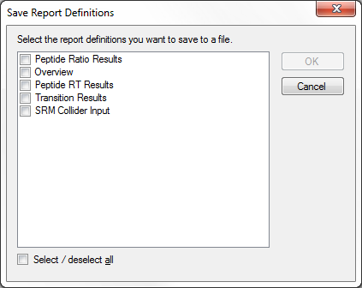

* Check ‘Overview’ in the report definitions list.
* Click the **OK** button.
* Enter ‘Overview’ in the **File name** field of the **Save As** form.
* Click the **Save** button.

The report template is saved to the file **Overview.skyr** in the **CustomReports** folder created for this tutorial. You could now share it with your collaborators, with your own analysis tool or as supplementary data for a manuscript.

# Managing Report Templates in Skyline

To gain an understanding of how others would use the custom report template you have now created and shared, you need to first delete it from your system. Then you can add it back using the shared report file **Overview.skyr** that you created in the previous section, as if you had acquired this shared template from another source.

The **Export Report** form should still be open after the steps performed in the previous section. To delete the ‘Overview’ report template from your Skyline settings, do the following:

* Click the **Edit List** button.
* Select the ‘Overview’ item in the **Report** list of the **Edit Reports** form.

The **Edit Reports** form should now look like:

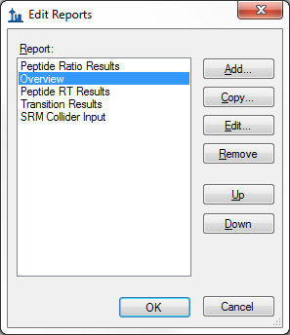

You can use the **Up** and **Down** buttons to change the order of the items in the **Report** list. To move the ‘Overview’ item to the bottom of the list, do the following:

* Click the **Down** button twice.
* Click the **Up** button three times to move the ‘Overview’ item to the top.

To remove the ‘Overview’ item from the list, do the following:

* Click the **Remove** button.
* Click the OK button.

The **Export Report** form should now look like:

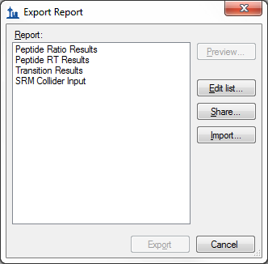

Just as when you first brought it up in this tutorial.

To demonstrate how your collaborators would import a new report template into Skyline follow the steps described below:

* Click the **Import** button.
* Select the ‘Overview.skyr’ file you created earlier in the **Open** form (which should still be showing the contents of the ‘CustomReports’ folder for this tutorial).
* Click the **Open** button.

These actions should add an ‘Overview’ item back to the **Report** list in the **Export Report** form. To verify that this is indeed the report you saved, perform the following steps:

* Select the ‘Overview’ item in the **Report** list.
* Click the **Preview** button.

Skyline will present a **Preview Report** form containing the same values you saw earlier in this tutorial.

# Modifying Existing Report Templates

You can, of course, create much more data rich reports than the simple ‘Overview’ report you first created in this tutorial. You can do this by creating another new report template, by editing your existing ‘Overview’ report, or, as shown below, by making a copy of the ‘Overview’ report and editing the copy. To create a new, more complex report from a copy of the ‘Overview’ report template, perform the following steps:

* Click on **Edit List** button in the **Export Report** form.
* Select the ‘Overview’ item in the **Report** list.
* Click on the **Copy** button.

Skyline will present the **Edit Report** form with the fields from the ‘Overview’ report template already added, as shown below:

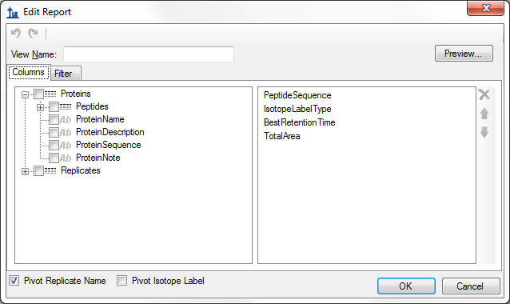

The report name for this new report template has not yet been assigned. To assign it now:

* Enter ’Study 7’ in the **View Name** field.

Continue to add more fields as described below by clicking the checkbox next to each field to add each field to the column list for your report template, on the right side of the **Edit Report** form:

* Expand the field groups **Peptides** and **Results** by clicking the **‘+’** icons to their left.
* From the expanded **Results** group, add the following fields:
  + **FileName** – the name of the file from which the data was imported
  + **SampleName** – the sample name, if the data was imported from a multi-sample WIFF file, or the file name again, if not
  + **ReplicateName** – the replicate name assigned to the data during import
* From the top level add **ProteinName**.
* From the expanded **Peptide** group, add the **AverageMeasuredRetentionTime** field – the average retention time over all replicates.
* Expand the **Results** group in the expanded **Peptide** group.
* From the expanded peptide **Results** group, add the following fields:
  + **PeptideRetentionTime** – peptide RT for each replicate run
  + **RatioToStandard** – area ratio of light to heavy
* Expandthe **Precursors** group.
* From the expanded **Precursors** group, add the following fields:
  + **Charge** (displayed in the column list as PrecursorCharge)
  + **Mz** (displayed in the column list as PrecursorMz )
* Expandthe **Transitions** group.
* From the expanded **Transitions** group, add the following fields:
  + **ProductCharge**
  + **ProductMz**
  + **FragmentIon** – the fragment ion name (e.g. y8, y10, b7, etc.)
* Expandthe **Results** group in the **Precursors** group.
* From the expanded precursor **Results** group, add the following fields:
  + **MaxFhwm** - the maximum full width at half max (FWHM) of the transitions for the particular precursor
  + **MinStartTime** - elution time start at the baseline of a peak, which will be the same for all transitions (Q1/Q3) from the same precursor
  + **MaxEndTime** - elution time start at the baseline of a peak, which will be the same for all transitions (Q1/Q3) from the same precursor
* Expandthe **Results** group in the **Transitions** group.
* From the expanded transition **Results** group, add the following fields:
  + **RetentionTime** – retention time at the maximum intensity for a transition peak
  + **Fwhm** – full width at half max for the transition peak
  + **StartTime** – retention time at the starting transition peak integration boundary
  + **EndTime** – retention time at the ending transition peak integration boundary
  + **Area** – area under the curve (AUC), minus background, for the transition peak
  + **Height** – maximum intensity for the transition peak
  + **UserSetPeak** - indicates whether or not (TRUE/FALSE) integration borders for a transition were manually adjusted
* Also, uncheck the **Pivot Replicate Name** checkbox, at the bottom of the form.

The report template should now contain a lot more detail than the original ‘Overview’ report template, and the **Edit Report** form should look like:

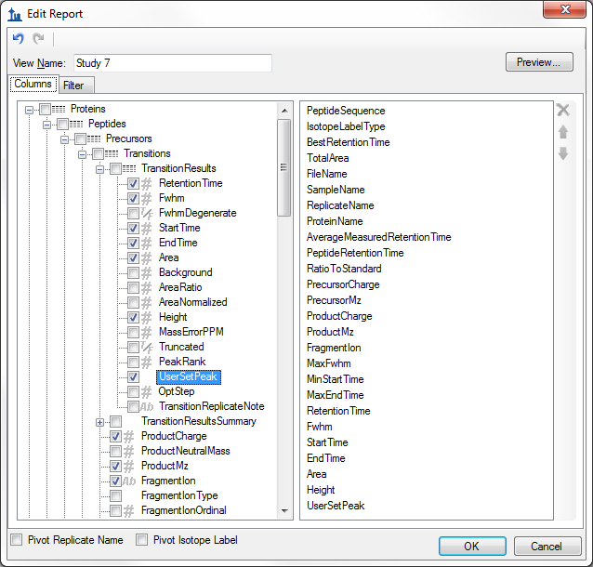

To reorder some fields in this new report template, do the following:

* Select **ProteinName** in the column list on the right.
* Click the up arrow on the far right until the **ProteinName** field is at the top of the list.

You can achieve whatever ordering suits you best, in this way, using the up and down arrow buttons on the far right, and you can remove fields you may have added by mistake with the red ‘X’ button above the arrow buttons. This tutorial, however, will continue without making any further changes to the column list.

To preview the values for the current document in the report template you have created, do the following:

* Click on the **Preview** button.
* When you have reviewed the data, close the preview form.

With data like this, where each peptide has both a light analyte and a matching heavy isotope labeled internal standard, it may be more convenient to work with the data for these paired precursors all in a single row to allow you to compare matching transition values more easily.

To make this change to the ‘Study 7’ report template, do the following:

* Checkthe **Pivot Isotope Label** check box.
* Click on the **Preview** button again to see how the report preview has changed.

All of the values for matching light and heavy transitions have been added to the same row. New columns have been added to achieve this, and columns specific to an isotope label type have been given the prefixes ‘light’ and ‘heavy’.

The **Preview** form is shown below, scrolled to show the transition between ‘light’ and ‘heavy’ column names:

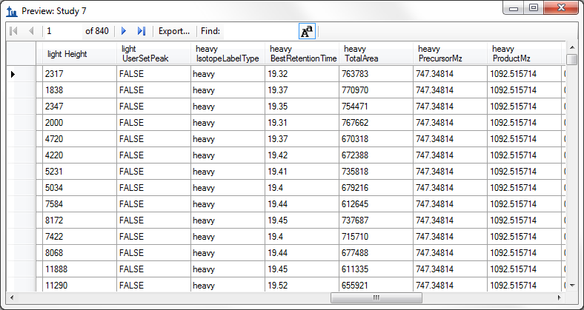

You might notice that the column ‘heavy IsotopeLabelType’ shows ‘heavy’ on every row, and that there is also a column ‘light IsotopeLabelType’ which shows ‘light’ on every column. When you are pivoting on a column, it does not add much to include it in your column list. Close the **Preview** form, and do the following to remove the ‘IsotopeLabelType’ field from this report:

* Select ‘IsotopeLabelType’ in the column list on the right.
* Click the red ‘**X**’ button on the far right edge of the column list.

You can click the **Preview** button again to verify that both the ‘light IsotopeLabelType’ and the ‘heavy IsotopeLabelType’ columns have been removed. The next step in this tutorial, however, is to save your work by doing the following:

* Click the **OK** button in the **Edit Report** form.
* Click the **OK** button in the **Edit Reports** form.

This will return you to the **Export Report** form, which should now look like:

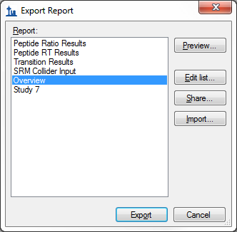

From here, you could now continue to export the new ‘Study 7’ report to a CSV file by selecting it and clicking the **Export** button, or click **Share** button to create file for sharing this new report. For this tutorial, however, click the **Cancel** button to return to the ‘Study7_example’ document.

# Quality Control Summary Reports

So far you have created reports based on the values Skyline offers for each imported replicate of the peptides and transitions specified in a document. Skyline also provides report fields with summary statistics across all imported replicates. These summary fields are particularly suited to quality control by ensuring that replicate QC runs show good reproducibility and coefficients of variation (CV). Skyline report templates can be designed with mean values and CV over all replicates for key parameters, such as peak area, FWHM and retention time.

This tutorial provides a summary report template that you will import into Skyline, but it also describes how to design such a summary report template in the **Edit Report** form.

To get started, first open a new document by doing the following:

* On the **File** menu, click **Open**.
* Navigate to the ‘CustomReports’ folder you created for this tutorial. (may not be necessary)
* Select the ‘Study9pilot.sky’ file.
* Click the **Open** button.

This file contains data acquired by one CPTAC site over 5 LC-MRM-MS runs, injecting 10 analyte peptides at a constant concentration of 50 fmol over all 5 runs. Such a dataset could potentially be used to assess reproducibility of replicate injections. In this part of the tutorial you will begin working with Live Reports, using the report to navigate around the document. To do this you will use the **Document Grid** functionality instead of **Export Report**.

To view the data for key quality control metrics follow the steps below:

* On the **View** menu, choose **Document Grid**.
* At the top of the **Document Grid** form, click the **Views** button. A dropdown list will appear..
* Choose **Manage Views** from the dropdown list.
* Click the import button in the **Manage Views** form
* Select the Summary_stats.skyr file from the ‘CustomReports’ folder in the **Open** form.
* Click the **Open** button.

A new view named ‘Summary Statistics’ should have been added to the **View** list, and the **Manage Views** form should now look like:

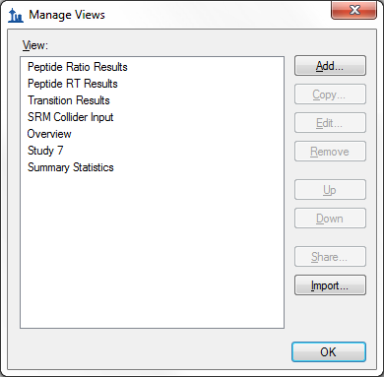

Click **OK** to dismiss the **Manage Views** form.

Then, on the **Document Grid** form, click the Views button and choose ***Summary Statistics***

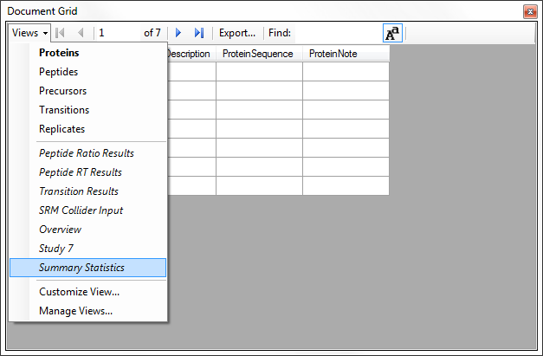

After you choose Summary Statistics, the document grid should look like the following:

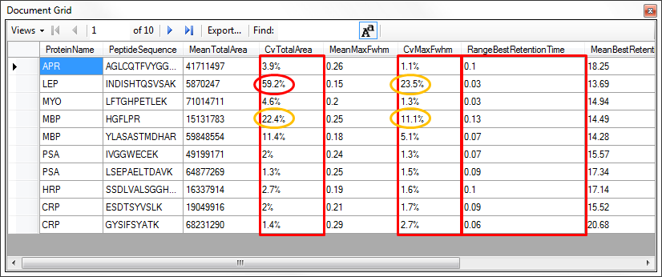

This report shows that the data in Study9pilot.sky, taken from 5 replicate injections of the same sample, produce peptide CV values for FWHM mostly below 5% and TotalArea in most cases under 10% as indicated for the corresponding columns with red boxes. In addition, the column called RangeBestRetentionTime (red box) lists the RT drift in minutes for any specific peptide over the 5 replicate injections. In this case there is only minimal RT drift (< 0.15 min, < 10 sec).

These summary reports can be used to flag quality control issues early, before they impact data acquired on important samples. In this particular dataset, HPLC and MS seem to behave acceptably. In one case, however, for the peptide INDISHTQSVSAK (from protein LEP), the CV value for TotalArea is 59.2% and for FWHM is 23.5% (circled in red), significantly differing from the CV values of all the other peptides.

You can add a filter to this view so that only rows matching specific criteria are shown by doing the following:

* Choose **Edit View** from the **Views** dropdown.
* In order to find the **CvTotalArea** column in the tree view on the left, double click on that column in the list on the right.

The **Customize View** form should look like:

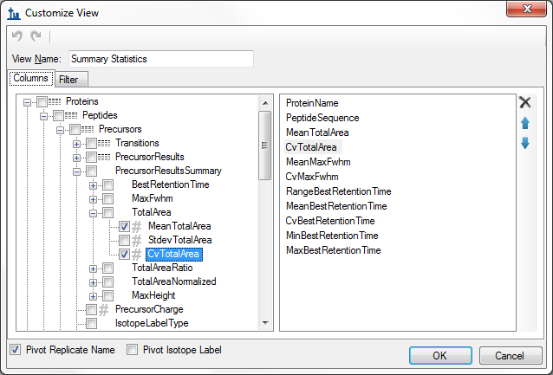

To define a new filter on this view:

* Click the **Filter** tab. The **CvTotalArea** column will still be selected in the tree view on the left.
* Click the **Add >>** button to add that column to the list of filters.
* Set the **Operation** to **Is Greater Than**
* In the **Value** column, enter ‘.2’**.**

The **Customize View** form should look like:

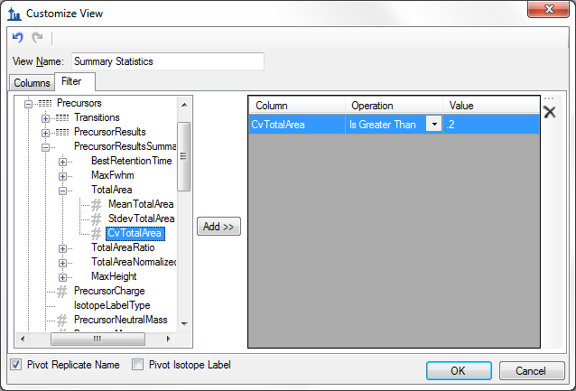

Note that even though the CvTotalArea column is displayed as a percentage in the Document Grid, on the filter tab, the number “20%” is represented as “.2”.

* Click the **OK** button on the **Customize View** form to see the rows matching this filter.

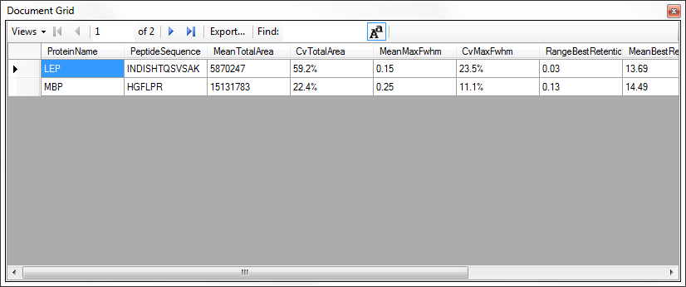

To inspect this peptide more closely, do the following:

* Close the **Document Grid** by clicking the red X in the upper right corner.
* Select the peptide ‘INDISHTQSVSAK’ in the peptide tree view.
* On the **View** menu, choose **Peak Areas**, and click **Replicate Comparison** (F7).

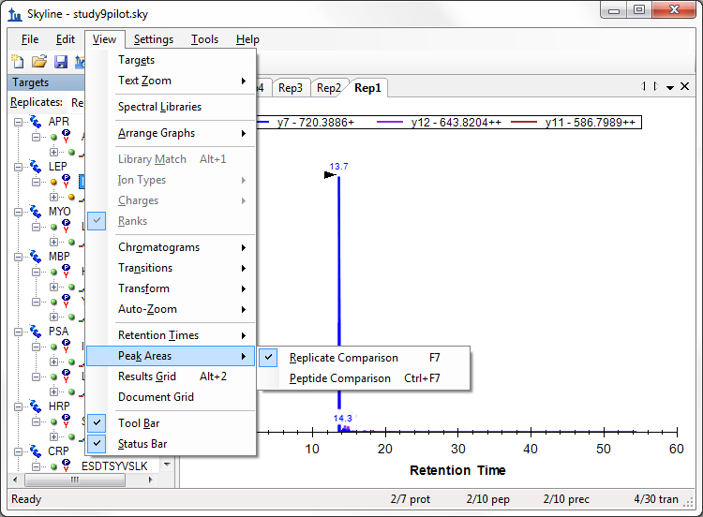

The **Peak Areas** view, showing the total peak area and the contribution of each transition for all 5 replicates, help clarify the problem that was indicated in the CV values of the summary report preview. For comparison, select several of the other peptides. The **Peak Areas** view will show much better peak area reproducibility, as indicated by their much lower TotalArea CV values in the summary report preview, where the majority of the peptides had CV values < 10%.

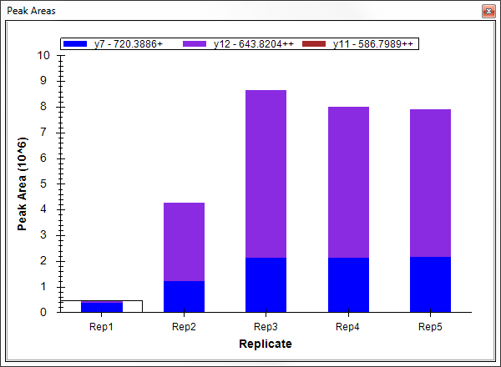

Skyline summary reports can be used with quality control data to flag issues early, while Skyline itself provides powerful visual displays to help get to the root of the problem quickly.

# Results Grid View

In some cases, you may want to see some of the values presented in reports while you are editing the data, for immediate access to raw values displayed in the Skyline charts. The Skyline **Results Grid** view provides real-time access to many of the data fields available in the custom reports. In the final sections of this tutorial, you will learn to use the **Results Grid** to gain immediate access to important values and to annotate your data to capture important human insights, as you inspect and refine your mass spectrometer output in Skyline.

To get started using the Result Grid view, do the following:

* On the **View** menu, click **Results Grid** (Alt-F2).

Skyline should now look something like this:

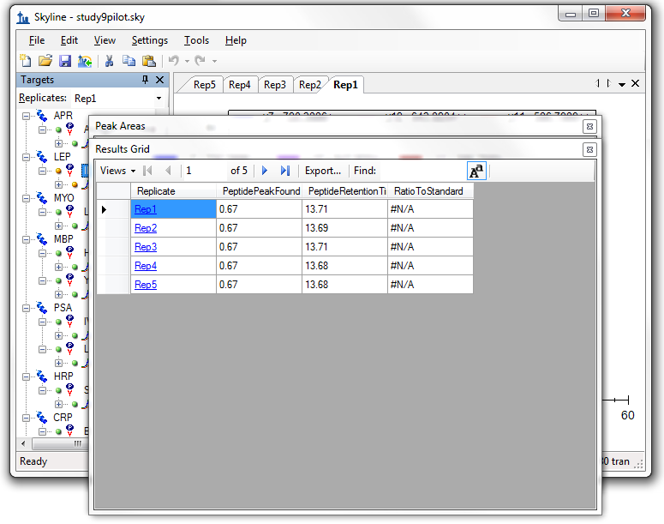

Now rearrange the windows for better viewing, by doing the following:

* Click the **Results Grid** caption and drag it to the bottom edge of the main window to dock it.
* Click the **Peak Areas** caption and drag it to the right edge of the main window to dock it.
* Click and drag the splitters between the various window panes to adjust the space allocation.
* On the **View** menu, choose **Auto-Zoom**, and click **Best Peak**, if it is not already selected.
* Select the precursor element ‘467.2440+++’ below the currently selected peptide.

This should leave Skyline looking something like:

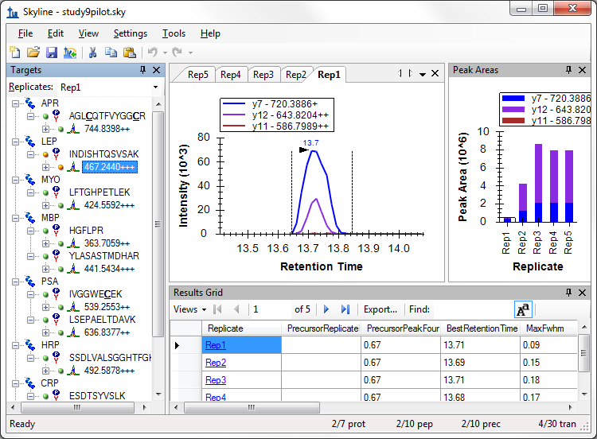

Skyline keeps its charts and the **Results Grid** in synch as you navigate the data. If you click on one of the other rows in the **Results Grid**, Skyline changes the active chromatogram replicate tab. It also changes which bar in the **Peak Areas** graph has the selection rectangle around it, as well as the selection in the **Replicates** list above the peptide tree view. Now click on a different chromatogram chart tab, bar in the **Peak Areas** chart, or change the selection in the **Replicates** list. The other views will update, including the selected row in the **Results Grid**.

The first column to the right of the **Replicate** column in the **Results Grid** is the **PrecursorReplicateNote**. This column allows you to associate a free text note with the **PrecursorResults** field group for the selected precursor and replicate.

* Type ‘Low signal’ in the first row with replicate name ‘Rep1’ for the currently selected peptide.

The **Results Grid** should now look like:

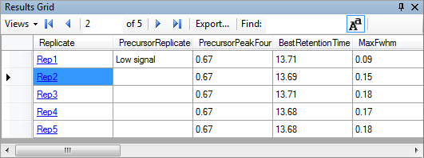

All of the other columns in the current **Results Grid** display are calculated by Skyline and cannot be edited, but you can change which columns get displayed and in what order. Several of the columns are scrolled out of view in the image above. To reduce the number of precursor results columns being displayed, do the following:

* From the **Views** dropdown at the top of the Results Grid, choose **Edit View**
* On the **Customize View** form, for each of the columns **Min Start Time**, **Max End Time**, and **Library Dot Product**, click on the column name in the list box, and then click on the X button to the right of the list box.
* Click the **OK** button.

You can now review the results for other precursors by doing the following:

* Click in the peptide tree view.
* Use the up and down arrow keys to change the selection to other precursor elements.

Finally expand a precursor and review its transitions. You could apply the same technique to customize the columns being displayed for transitions. Instead, continue now to the final section in this tutorial to learn how to add a custom annotation that you can control with the **Results Grid**, and later export in a Skyline report.

# Custom Annotations

Skyline supports three types of custom annotations:

1. Free text (similar to the **Note** which is available by default on all types)
2. Number
3. True/False
4. Value list

The last two types can be used to collect information in a controlled vocabulary, as you process your data, which can later be exported in a Skyline report and used as input for programmatic statistical analysis.

To define a simple new True/False annotation, perform the following steps:

* On the **Settings** menu, click **Annotations**.
* Click the **Edit List** button on the **Annotation Settings** form.
* Click the **Add** button on the **Define Annotations** form.
* Type ‘Tailing’ in the **Name** field on the **Define Annotation** form.
* Select ‘True/False’ in the **Type** field.
* Check the **Precursor Results** checkbox in the **Applies To** list.

The **Define Annotation** from should now look like:

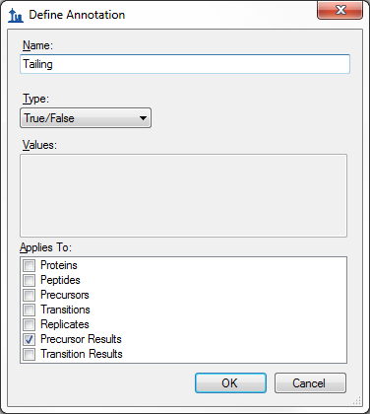

Now finish defining the annotation and add it to your document by doing the following:

* Click the **OK** button on the **Define Annotation** form.
* Click the **OK** button on the **Define Annotations** form.
* Check the checkbox for the new ‘Tailing’ annotation.

The **Annotation Settings** form should now look like:

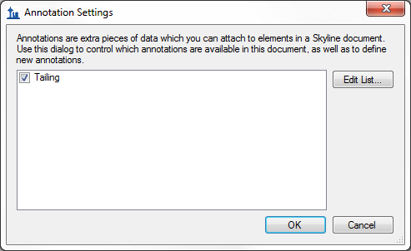

* Click the **OK** button.

Select the second to last precursor element ‘564.7746++’ for the peptide ‘ESDTSYVSLK’.

The new Tailing column will not have been added to the custom view in the **Results Grid**, but you can add it:

* Choose **Edit View** from the **Views** dropdown at the top of the **Results Grid**.
* In the list view on the right, click on the third column down (“**PrecursorPeakFoundRatio**”). This will affect where in the list new columns get added.
* Click the checkbox next to **Tailing** at the bottom of the tree view on the left.

The **Customize View** form should now look like the following:

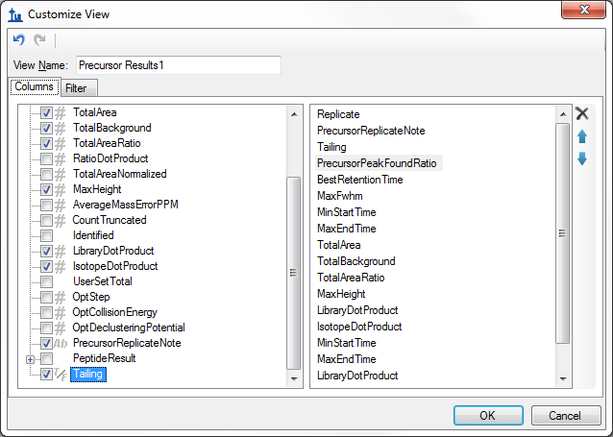

* Click the **OK** button.

You should see the new **Tailing** column added to the **Results Grid** between **PrecursorReplicateNote** and **PrecursorPeakFoundRatio**

The Skyline window should now look something like:

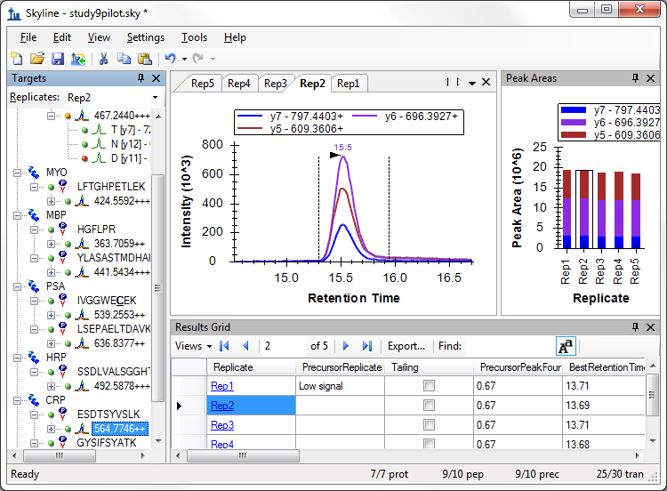

The peaks in this document do not have a lot of issues, but this one does have some peak tailing. Check the checkbox in the new **Tailing** column for the ‘Rep1’ row. Change selection to each of the other 5 rows. Decide whether you think the tailing is worth noting and check the checkbox, if you think it is. Change the selected item in the precursor tree and then return to the ‘564.7746++’ precursor to verify that your changes were recorded.

You can now export the new **Tailing** annotation in a Skyline custom report. It will appear in the **PrecursorResults** field group.

# Conclusion

This tutorial has introduced you to the flexible custom reports Skyline offers for accessing the rich set of values associated with your Skyline targeted proteomics documents. These reports offer a smooth path from data analysis within Skyline to more complex statistical analysis with Excel or custom programs in R, Matlab, Java or C++. You have learned about summary statistics available through these report templates, which can provide quick indicators of data quality. You can share your custom report templates with collaborators or as supplementary material in your publications, helping others to repeat your analyses with new data sets even from different instrumentation, taking full advantage of the Skyline multi-vendor support. Finally, you learned how to use the Skyline Results Grid to gain immediate access to many of the values available in Skyline reports and to work with custom annotations to add rich new information to your documents. If you were not aware of these features before, they will certainly increase the scope of experiment you can achieve with Skyline.

# Glossary of Custom Report Fields

* **Proteins** (top level)**:**
  + **ProteinName** – Protein Name as defined or entered into Skyline (in some cases in conjunction with the accession number).
  + **ProteinDescription** – When proteins are imported into Skyline through public FASTA sequence files, a Protein Description is provided. You can see the Protein Description also when you hover over the protein name in the peptide tree view.
  + **ProteinSequence –** When proteins are imported into Skyline through public FASTA sequence files the full protein sequence is accessible. You can see the protein sequence also when you hover over the protein name in the peptide tree view.
  + **ProteinNote** – A free text note associated with the protein by clicking Edit Note on the Edit menu.
  + **[Protein Annotations]** – Annotations defined as applying to “Proteins” appear here.
* **Results** (top level)**:**
* **ReplicateName** – The replicate name assigned to the data during import.
* **ReplicatePath** – Reserved for future use.
* **FileName** – The name of the file from which the data was imported.
* **SampleName** – The sample name, if the data was imported from a multi-sample WIFF file, or the file name again for other file types.
* **ModifiedTime** – Last time and date at which the original mass spectrometer file was modified on disk.
* **AcquiredTime** – Last time and date at which the mass spectrometer began acquiring this replicate data. Or #N/A if the file was imported with a version older than 1.1.
* **[Replicate Annotations]** – Annotations defined as applying to “Replicates” appear here.
* **Peptides:**
  + **PeptideSequence** – Amino acid sequence of the peptide **.**
  + **PeptideModifiedSequence** – Amino acid sequence annotated with only structural modification delta masses (e.g. AC[+57]GR).
  + **BeginPos** – The position of the first (N-terminal) amino acid of the peptide within its containing protein sequence, or #N/A if no protein sequence is available.
  + **EndPos –** The position of the last (C-terminal) amino acid of the peptide within its containing protein sequence, or #N/A if no protein sequence is available.
  + **MissedCleavages** – The number of missed cleavage sites in the peptide sequence.
  + **RetentionTimeCalculatorScore** – The raw score for the peptide from the current retention score calculator, if one is used (e.g. SSRCalc or iRT score)
  + **PredictedRetentionTime** – The retention time predicted by a retention time regression between a set of measured results and a retention time calculator (currently only SSRCalc 3.0 is available), or #N/A if no retention time regression has been assigned.
  + **AverageMeasuredRetentionTime –** The average peptide retention time over all replicates.
  + **PeptideNote –** A free text note associated with the peptide by clicking Edit Note on the Edit menu.
  + **[Peptide Annotations] –** Annotations defined as applying to “Peptides” appear here.
* **PeptideResults** (per replicate values)**:**
  + **PeptidePeakFoundRatio** – The ratio of transitions for which a peak was measured to the total number of transitions in the peptide. Peak indicators in the peptide tree view correspond to green = 1.0 (all transitions integrated), orange >= 0.5, red < 0.5.
  + **PeptideRetentionTime** – Peptide retention time for each replicate run.
  + **PredictedResultRetentionTime** – Retention time predicted for this specific replicate based on retention time alignment of iRT values.
  + **RatioToStandard** – Peptide area ratio of light to heavy.
  + **BestReplicate** – True if this replicate has the highest overall peptide peak score.
* **Precursors:**
  + **Charge/PrecursorCharge** – The charge associated with the precursor ion.
  + **IsotopeLabelType** – A label type name associated with the precursor ion (light/heavy), indicating which isotope modifications are applied.
  + **PrecursorNeutralMass** – Neutral mass of the precursor in Daltons.
  + **Mz/PrecursorMz** –The mass to charge ratio (*m/z*) of the precursor ion.
  + **CollisionEnergy** - Collision Energy for the precursor ion according to instrument/vendor specific default collision energy equation within Skyline.
  + **DeclusteringPotential** - Declustering Potential for the precursor ion according to instrument/vendor specific default declustering potential equation within Skyline.
  + **ModifiedSequence** - Peptide sequence including any amino acid modifications such as cysteine alkylation. (example: AGLC[+57]QTFVYGGC[+57]R)
  + **PrecursorNote** – A free text note associated with a precursor by clicking Edit Note on the Edit menu.
  + **LibraryName** – The name of a MS/MS spectral library, if a MS/MS spectral library spectrum is associated with the precursor ion.
  + **LibraryType** – The type of MS/MS spectral library (BiblioSpec, GPM, NIST), if a MS/MS spectral library spectrum is associated with the precursor ion.
  + **PrecursorLibraryRank** – A MS/MS spectral library ranking of the precursor among other precursors for a protein that match supplied spectral libraries, using a score specified in the peptide library settings.
  + **LibraryScore1** – Raw peptide library score that may or may not be used to rank among precursors of a protein.
  + **LibraryScore2** – Raw peptide library score that may or may not be used to rank among precursors of a protein.
  + **LibraryScore3** – Raw peptide library score that may or may not be used to rank among precursors of a protein.
  + **IsDecoy/PrecursorIsDecoy** – True if this is a decoy precursor.
  + **DecoyMzShift/PrecursorDecoyMzShift** – Shift in *m/z* applied to the precursor to create the decoy *m/z*.
  + **[Precursor Annotations]** – Annotations defined as applying to “Precursors” appear here.
* **PrecursorResults** (per replicate values)**:**
* **PrecursorPeakFoundRatio –** The ratio of transitions for which a peak was measured to the total number of transitions in the precursor. Peak indicators in the peptide tree view correspond to green = 1.0 (all transitions integrated), orange >= 0.5, red < 0.5.
* **BestRetentionTime** – The **RetentionTime** value of the transition with the highest maximum intensity for the precursor.
* **MaxFwhm** – The maximum full width at half max (FWHM) of the transitions for the precursor.
* **MinStartTime** – Minimum **StartTime** of all transitions for a precursor. Unless manually edited all transitions for a precursor use the same integration boundaries.
* **MaxEndTime –** Maximum **EndTime** of all transitions for a precursor. Unless manually edited all transitions for a precursor use the same integration boundaries.
* **TotalArea** – The summed **Area** values of all individual transitions for the particular precursor.
* **TotalBackground** – The summed **Background** values of all individual transitions for the particular precursor.
* **TotalAreaRatio** – The ratio of the **TotalArea** of this precursor to the first internal standard label type, before version 0.7 this was always light/heavy, and appeared on the heavy precursor.
* **TotalAreaNormalized** – The **TotalArea** normalized to the sum of the **TotalArea** values for all peptide precursors in the document.
* **CountTruncated**– The number of transitions for a precursor that integrate a peak with a boundary at either end of the acquisition time range, where intensity at the end is greater than 1% of the entire peak height higher than the other extent.
* **Identified** – True if a MS/MS peptide identification exists for the result file at a time between the peak integration boundaries. *(new in v1.2)*
* **LibraryDotProduct** – The dot-product (described by Wikipedia <http://en.wikipedia.org/wiki/Dot_product>) between the individual transition peak areas of the precursor and the intensities of the matching ion peaks in the matched MS/MS spectral library spectrum (*Note: as of v1.4, this is now 1 – Arcos(dotp)/(Pi/2) where dotp is the value described above. a.k.a. Normalize Spectrum Contrast Angle*), or #N/A if the precursor has not matching library spectrum or has fewer than 4 transitions. This is a useful value for method refinement. It works best when 6 or more transitions are present.
* **IsotopeDotProduct** – The dot-product calculation described above, but between the individual precursor (M, M+1, M+2, etc.) peak areas of the precursor and the intensities of the predicted isotope distribution, or #N/A if the transition is not a precursor isotope, or the chromatogram was not extracted from high resolution MS1 data. *(new in v1.2)*
* **UserSetTotal** – True if the default choice of peak or its boundaries was manually altered.
* **OptStep** – Optimization step value indicating distance from the default value for the parameter being optimized, 0 for the default parameter value, or if no optimization is being performed in the replicate.
* **OptCollisionEnergy** – The collision energy value corresponding to the **OptStep** if collision energy optimization is being performed.
* **OptDeclusteringPotential** – The dlecustering potential value corresponding to the **OptStep** if declustering potential optimization is being performed.
* **PrecursorReplicateNote** – A free text note associated with a result set of the precursor using the Results Grid.
* **[Precursor Results Annotations]** – Annotations defined as applying to “Precursor Results” appear here.
* **PrecursorResultsSummary** (summary statistics across all replicates):
  + **MinBestRetentionTime** – Minimum of the precursor **BestRetentionTime** values.
  + **MaxBestRetentionTime** – Maximum of the precursor **BestRetentionTime** values.
  + **RangeBestRetentionTime** – The difference between **MaxBestRetentionTime** and **MinBestRetentionTime**, which can be used to gauge the spread of retention times measured.
  + **MeanBestRetentionTime** – Mean of the precursor **BestRetentionTime** values.
  + **StdevBestRetentionTime** – Standard deviation of the precursor **BestRetentionTime** values.
  + **CvBestRetentionTime** – Coefficient of variation (CV) of the precursor **BestRetentionTime** values.
  + **MeanMaxFwhm** – Mean of the precursor **MaxFwhm** (peak width) values.
  + **StdevMaxFwhm** – Standard deviation of the precursor **MaxFwhm** (peak width) values.
  + **CvMaxFwhm** – Coefficient of variation (CV) of the precursor **MaxFwhm** (peak width) values.
  + **MeanTotalArea –** Mean of the precursor **TotalArea** values.
  + **StdevTotalArea** – Standard deviation of the precursor **TotalArea** values.
  + **CvTotalArea** – Coefficient of variation (CV) of the precursor **TotalArea** values.
  + **MeanTotalAreaRatio** – Mean of the precursor **TotalAreaRatio** values.
  + **StdevTotalAreaRatio** – Standard deviation of the precursor **TotalAreaRatio** values.
  + **CvTotalAreaRatio** – Coefficient of variation (CV) of the precursor **TotalAreaRatio** values.
  + **MeanTotalAreaNormalized** – Mean of the precursor **TotalAreaNormalized** values.
  + **StdevTotalAreaNormalized** – Standard deviation of the precursor **TotalAreaNormalized** values.
  + **CvTotalAreaNormalized** – Coefficient of variation (CV) of the precursor **TotalAreaNormalized** values.
* **Transitions:**
* **ProductCharge** – Charge (z) of the product ion.
* **ProductNeutralMass** - Neutral mass of the product ion peptide fragment in Daltons.
* **ProductMz** – The mass to charge ratio (*m/*z) of the product ion.
* **FragmentIon** – The name of the product ion peptide fragment (e.g. y8, y10, b7, etc.).
* **FragmentIonType** – The type of the product ion (y, b, c, z, a, x, precursor)
* **FragmentIonOrdinal** – Position of the amino acid in the peptide after (C-terminal of) which the peptide was cleaved upon fragmentation. (e.g. 8, 10, 7, etc.)
* **CleavageAa –** Specific amino acid residue in the peptide after (C-terminal of) which the peptide was cleaved upon fragmentation. (e.g. P, M, S, T, etc.)
* **LossNeutralMass –** The total mass of all neutral losses from this fragment.
* **Losses –** A comma separated list of all neutral losses from this fragment.
* **TransitionNote** – A free text note associated with the transition by clicking Edit Note on the Edit menu.
* **LibraryRank** – The rank based on **LibraryIntensity** of this transition among all transitions allowed by the transition **Filter** settings, shown in the user interface as “(rank #)”.
* **LibraryIntensity** – The MS/MS peak intensity corresponding to the transition product ion in the matching library spectrum.
* **IsotopeDistIndex** – Zero for the monoisotopic peak, 1 for M+1, 2 for M+2, etc. *(new in v1.2)*
* **IsotopeDistRank** – The rank based on the **IsotopeDistProportion** among all isotope peaks for the predicted isotope distribution, shown in the user interface as “(irank #)”. Currently only available for precursor transitions filtered from high resolution MS1 scans. *(new in v1.2)*
* **IsotopeDistProportion** – The proportion of the entire isotope distribution predicted for this isotope peak. Currently only available for precursor transitions filtered from high resolution MS1 scans. *(new in v1.2)*
* **IsDecoy/TransitionIsDecoy –** True if this is a decoy transition.
  + **DecoyMzShift/ProductDecoyMzShift** – Shift in *m/z* applied to the product ion to create the decoy *m/z*.
  + **[Transition Annotations]** – Annotations defined as applying to “Transitions” appear here.
* **TransitionResults:**
* **RetentionTime** – Retention time at the maximum intensity for a transition peak.
* **Fwhm** – Full width at half max (FWHM) for the transition peak.
* **FwhmDegenerate** – True if one of the peak integration boundaries intersects the chromatogram above the half maximum intensity.
* **StartTime** – Retention time at the starting integration boundary for the transition peak.
* **EndTime** – Retention time at the ending integration boundary for the transition peak.
* **Area** – Area under the curve (AUC), minus background, for the transition peak.
* **Background** – The area of the rectangle formed by the integration boundaries, and the baseline and a line perpendicular to minimum intersection intensity between the integration boundaries and the chromatogram for the transition peak.
* **AreaRatio** – The ratio of the **Area** of this transition to its corresponding transition in the first internal standard label type, before version 0.7 this was always light/heavy, and appeared on the heavy transitions.
* **AreaNormalized** - The **Area** normalized to the sum of the **Area** values for all transitions in the document.
* **Height** – The maximum intensity of the points between the transition peak integration boundaries.
* **Truncated**– True if the integrated a peak has a boundary at either end of the acquisition time range, where intensity at the end is greater than 1% of the entire peak height higher than the other extent. Or #N/A if the data was imported with a version older than 1.1.
* **PeakRank** – The rank based on **Area** of this transition among all other transitions of the same precursor.
* **UserSetPeak** – True if the default choice of peak or its boundaries was manually altered.
* **TransitionReplicateNote** - A free text note associated with a result set of the transition using the Results Grid.
* **[Transition Results Annotations]** – Annotations defined as applying to “Transition Results” appear here.
* **TransitionResultsSummary** (summary statistics across all replicates):
  + **MinRetentionTime** – Minimum of the transition **RetentionTime** values.
  + **MaxRetentionTime** – Maximum of the transition **RetentionTime** values.
  + **RangeRetentionTime** – The difference between **MaxRetentionTime** and **MinRetentionTime**, which can be used to gauge the spread of retention times measured.
  + **MeanRetentionTime** – Mean of the transition **RetentionTime** values.
  + **StdevRetentionTime** – Standard deviation of the transition **RetentionTime** values.
  + **CvRetentionTime** – Coefficient of variation (CV) of the transition **RetentionTime** values.
  + **MeanFwhm** - Mean of the transition **Fwhm** (peak width) values.
  + **StdevFwhm** - Standard deviation of the transition **Fwhm** (peak width) values.
  + **CvFwhm** - Coefficient of variation (CV) of the transition **Fwhm** (peak width) values.
  + **MeanArea** - Mean of the transition **Area** values.
  + **StdevArea**- Standard deviation of the transition **Area** values.
  + **CvArea** - Coefficient of variation (CV) of the transition **Area** values.
  + **MeanAreaRatio** - Mean of the transition **AreaRatio** values.
  + **StdevAreaRatio** - Standard deviation of the transition **AreaRatio** values.
  + **CvAreaRatio** - Coefficient of variation (CV) of the transition **AreaRatio** values.
  + **MeanAreaNormalized** - Mean of the transition **AreaNormalized** values.
  + **StdevAreaNormalized** - Standard deviation of the transition **AreaNormalized** values.
  + **CvAreaNormalized** - Coefficient of variation (CV) of the transition **AreaNormalized** values.